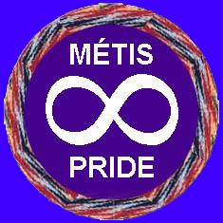
KESPU’KWITK MÉTIS COUNCIL
Mailing & Office Address: 368 Main Street, Lovitt Plaza, Suite 221
Yarmouth, NS B5A 1E9
Email Address: kmcmetis@gmail.com
Website: www.kmcmetis.ca Phone: 902-742-6591
Application of registration for membership as mentioned under the by-laws of Kespu’kwitk Métis Council.

REACTIVATION CARD for members who want to rejoin KMC# ________

Surname: ___________________ Maiden Name (if applicable) ____________________

First & Middle Names _____________________________________________________

Mailing Address: _________________________________________________________

Town/City: _______________________Province: _______ Postal Code: __________

Date of Birth: _____________ / ____________ / ____________
Day Month Year

Telephone Home: __________________ Work or Cell: _________________________

E-mail: _________________________________________________________________

_________________________________________
APPLICANT’S SIGNATURE

______________ / _____________ / ______________
Day Month Year

Please include a current “passport size” headshot photo with your reactivation (good quality photos only). Photocopied ID cards no longer accepted.

PLEASE RETURN THE COMPLETED FORM, PHOTO, AND YOUR EXPIRED KMC CARD TO:
Kespu’kwitk Metis Council, P.O. Box 424, Yarmouth, N.S. B5A 4B3
OR email the completed form, and a headshot photo taken from a mobile phone. Payment may be made by cheque, cash or E-transfer at this email address.
THERE IS A FEE OF $75.00

PREVIOUS CARD NUMBER: ________________________________

For office use only / NEW CARD NUMBER: ____________________

